**Year 8 Science (M)**

**2021**

**Topic Test:**

**Periodic Table, Atomic Structure & Kinetic Theory**

**Name: _________________________ Marks: 45**

**Teacher: _______________________**



**Materials Required:**

* **Blue/black ballpoint pen**
* **Pencil**
* **Ruler**
* **Eraser**
* **Calculator**

|  |  |  |
| --- | --- | --- |
| **Section 1**  **(10)** | **Section 2**  **(35)** | **Total**  **(45)** |
|  |  |  |

**Section 1: Multiple Choice [10 Marks]**

**Circle the letter of the most correct answer for each of the statements or questions below.**

1. Which of the following statements about the particles in an atom is correct?

1. Protons and electrons are found in the nucleus
2. Only protons are found in the nucleus
3. Neutrons are positively charged
4. Protons are negatively charged
5. The charge of an electron is
6. Positive
7. Negative
8. No charge
9. None of the above
10. To be called “matter”, a substance must have
11. Shape and volume
12. A weight over 1kg
13. Mass and volume
14. Feelings
15. The lightest known element is what?
16. Hydrogen
17. Gold
18. Silver
19. Aluminum
20. Which of the following statements about the particles in an atom is correct?

1. Protons are not found in the nucleus
2. Protons and neutrons are found in the nucleus
3. Neutrons are positively charged
4. Atom particles are around the size of your finger
5. The Kinetic Theory of Matter states that all matter (everything on earth) is made up of
6. Electrons moving everywhere
7. Just solids
8. Gases and liquids
9. Small moving particles
10. The atomic number of an element is equal to its number of
11. Atoms
12. Subatomic particles
13. Protons
14. Neutrons
15. How can you tell when something is a solid?
16. It will pour
17. It takes the shape of its container
18. It cannot be seen easily
19. It will hold its shape
20. When you add heat to a substance which of the following occurs?
21. Particles become more attracted
22. Particles get larger
23. Particles move faster
24. Particles get smaller

10.LXR 8332 No 88A cylinder is filled with two liquids **X** and **Y**. Two different solid objects **W** and **Z** are placed in the liquids and are found to position themselves as shown in the diagram below:



The order of the four substances, from most dense to least dense is:

1. Z, X, Y, W
2. Z, Y, X, W
3. Z, W, Y, X
4. W, X, Y, Z

**End of Section 1**

**Section 2: Short Answers [35 Marks]**

**Answer ALL questions in the spaces provided below. Use a blue or black pen unless you have been asked to draw a diagram.**

**Question 11 [10 Marks]**

The symbols or names of several chemical elements are presented in the table below. Complete the table by filling in the correct name or symbol of each element in the appropriate space.

|  |  |
| --- | --- |
| **Symbol** | **Element Name** |
| H |  |
| He |  |
| Li |  |
| Be |  |
| C |  |
|  | Oxygen |
|  | Neon |
|  | Boron |
|  | Sodium |
|  | Magnesium |

**Question 12 [6 Marks]**

a. Complete the table below by drawing a simple illustration to show the Particle Model of the three states of matter inside a container. You do not need to ‘fill’ the whole container. (3 marks)

|  |  |  |
| --- | --- | --- |
| **Solid** | ngle,Area,Cylinder PNG Clipart - Royalty Free SVG / PNG**Liquid** | **Gas** |
| ngle,Area,Cylinder PNG Clipart - Royalty Free SVG / PNG |  | ngle,Area,Cylinder PNG Clipart - Royalty Free SVG / PNG |

b. Briefly describe how the particles are positioned and how they move in each of these states. (3 marks)

Solid:_____________________________________________________________________________________________________________________________________________________________________________________________________

Liquid:____________________________________________________________________________________________________________________________________________________________________________________________________

Gas:______________________________________________________________________________________________________________________________________________________________________________________________________

**Question 13 [10 Marks]**

Select the objects from the in the box below that best matches the states of matter in the table. Each term may be used only once. Cross the objects off once written in the table.

|  |
| --- |
| **ice ; carbon dioxide ; petrol ; iron ; cooking oil ; helium; diamonds ; steam ; t-shirt ; sweat** |

|  |  |  |
| --- | --- | --- |
| Solid | Liquid | Gas |
|  |  |  |

**Question 14 [4 Marks]**

Refer to the diagram of a Lithium atom, fill-in the 5 labels. The first one has already been done for you.

Electron Shell

Question 19 [5 Marks]

This illustration shows the changes of state between the three types of matter. Place each word from the box below in the correct place on the diagram.

|  |
| --- |
| liquid ; freezing ; cooling ; melting ; gas |

Sublimation

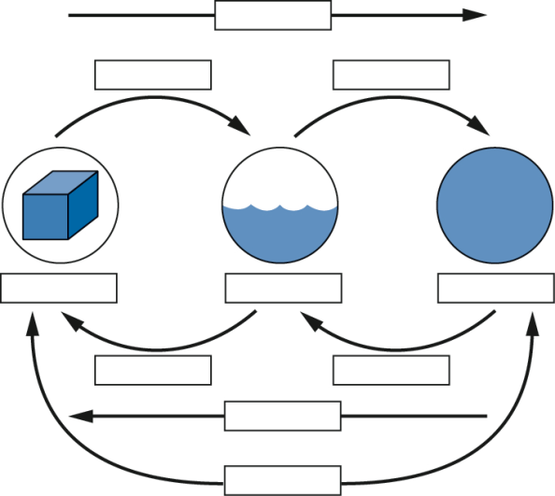

Solid

Evaporating

Condensing

Heating

**End of Test**